## Adithya G – 18BCS102

### Internet and Web Programming

#### Assignment 3 –HTML Resume with 3 types of CSS

**Aim:**

To add 3 types of CSS to my resume created using pure HTML in the 1st assignment.

**Procedure:**

* Create repository and create webpage using a text editor.

* Check out web page on a web browser

* Upload to GitHub using your SCM tool.

**Source Code:**

[Click here!](https://github.com/aad8ya/Internet-and-Web-Programming/tree/main/Assignment%203%20-%203%20types%20of%20CSS%20to%20Resume%20HTML%20Page) for source code

**Output:**

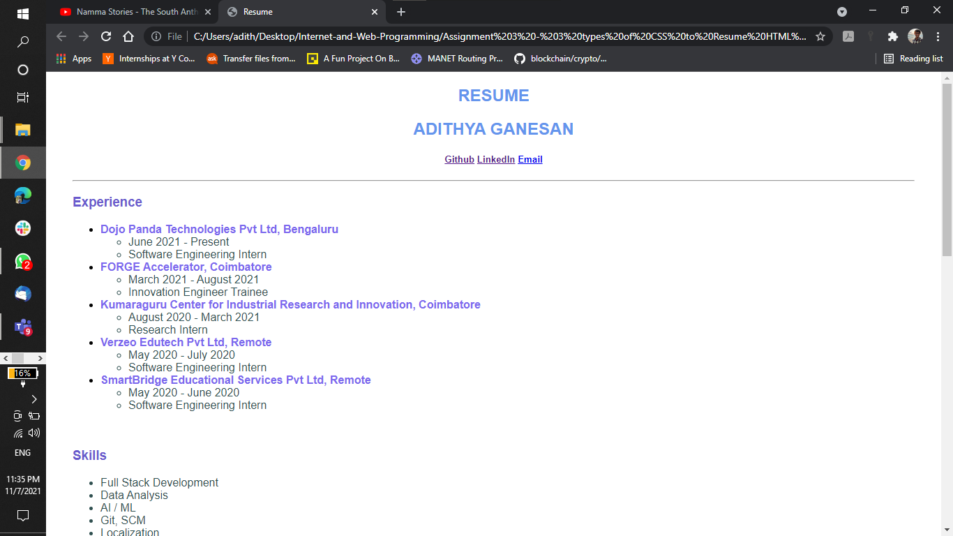

**Result:**

Thus, we have added 3 types of CSS to my resume created using HTML.